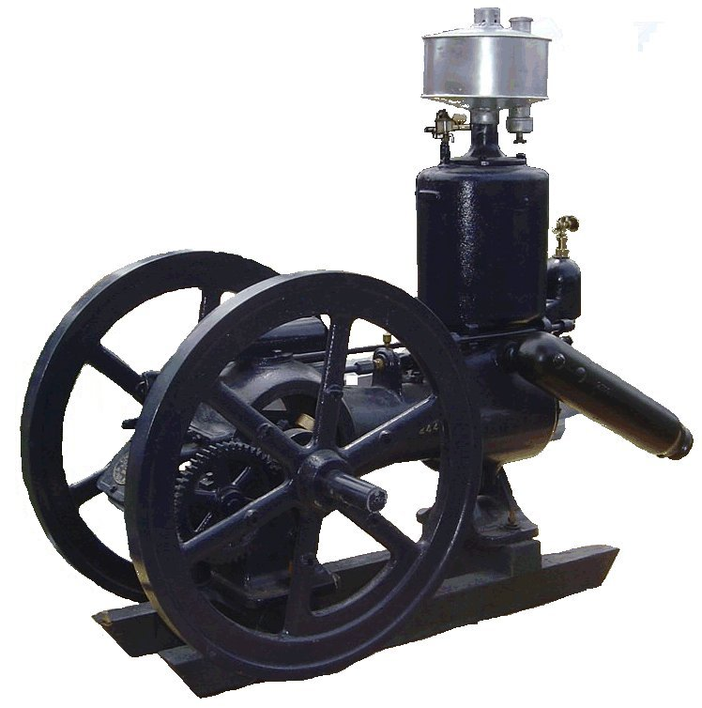
F O O T H I L L S

ANTIQUE POWER ASSOCIATION
ESTABLISHED 2003

Dear Members, August 2016
Since we did not have a July meeting, we have quite a few things to catch up on and, given that the next couple months are when the fall shows and events start, we’ll try to keep you updated. Of course, we cannot cover everything in the newsletter, only the highlights. We encourage all who can to come to the monthly meetings to do so, not only for the straight skinny on the happenings of our organization, but also the fellowship that we all enjoy.

--- --- --- from the August meeting --- --- ---

- We continue to have quite a few members, friends, and family members on our prayer list. I’m sure there are several others whose names could be added, but these are the ones we have been informed of. Of course, we ought to pray for one another each day, not just because one or two of us has a special need, but because this world can be a rough place and it seems to be getting rougher by the minute. Let us not forget to pray.

  - Timmy Jones
  - Ray Weaver
  - Vicki Danner
  - Doug Huffman
  - Cole Abernathy
  - Ann Little
  - Kenneth Beach
  - Powell Sigmon
  - Vee Williams

  - Larry Sigmon
  - Donnie Elmore
  - Linda Sigmon
  - Lorna Sheets
  - Billie Sue Goforth
  - Steve Hefner
  - Wade Hefner
  - Norris Turner
  - Terry Martin
  - Eugene Hartley
  - Ira & Ann Cline
  - Howard Cooper
  - Kelly Blanton
  - Dot Hawn
  - Rev. Bobby Langston
  - Allen Everdyke
  - Don Johnson
  - Carl Porter
  - Jane Abernathy

- The Show Committee met in July and hashed out an equitable distribution of the proceeds from the 2016 show. That proposal was presented to the membership at the August meeting and was unanimously voted as the way we should proceed. Of course, due to the inclement weather this year, the proceeds are somewhat short of last year (by almost $10,000). Here is the breakdown of how the total of $13,500 is to be distributed.
    - Hospice $3000
    - Family Care Center $3000
    - NC Veteran’s Home $2500
    - Children’s Advocacy Ctr $2500
    - Catawba Co. 4H $ 500
    - Camp Tekoa $ 500
    - BH ROTC $ 500
    - FAPA Improvement fund $1500

- The American Legion Fair is coming up August 31 through September 1.
  - Once again, we hope to be a big part of the festivities by filling the pole shed and store building display areas (and more if needed).
    - You can bring in your display items any time starting on Aug 28. Let’s do our part to help make this year’s fair more than a carnival.
  - We’ll need some help, of course, in several areas.
    - The pole shed – help is needed to keep an eye on things. See Bill Harris to help.
    - The store building – help is needed to keep an eye on things – see Howard Reinhardt to help.
    - The saw mill – help is needed to run the demonstrations (off-bearing, hacking, and slab-sawing). See Dale Reese to help.

- The Swap meet is coming up September 17. It will be much as it was last year: gates open at 6AM for sellers, 7AM for the public. Entry fee is $5 per person for all who come through the gate (12 & over).
  - So gather up your stuff and bring it to the fairgrounds that morning.
  - If you don’t have anything to sell, come looking to buy. Who knows, you might find that one thing you have been looking for.

- The Building Fund Raffle dinner will be held the same evening as the swap meet in Bethel Lutheran Ch. Fellowship Hall.
  - This year we will be featuring Barbeque (all you can eat) and all the fixin’s and all will be prepared by our members.
  - As for the desserts, we once again call upon our ladies (and those men so inclined) to prepare the dainty treats we have come to enjoy so much over the last several years.
  - The Raffle will be as before. Tickets are on sale now. You can get them from Ned Story, Wilson Sigmon, Tim Hollar, and a few others. They are $50 each, entitling the bearer to two meals and 1 chance in the drawing: the grand prize being $3000 cash.
  - We will also be needing some volunteers to help set up the night before.

- During the May meeting, we had decided to keep the price of the remaining tee-shirts at $10 until fair time. We’ve thought more about that and, in order to get our sponsor’s names out in the public view as was our intent, we decided to change that and reduce the price to $5 now.
  - The remaining 2016 tee-shirts are available for purchase (while supplies last) at $5.
  - We’ll have some at the fair. You can also pick one or two up a Sig’s Tire.

- The upcoming October meeting (less than two months away) will feature the election of officers and board members. Anyone who is willing to serve in some capacity is asked to contact any of the current officers and board members. We really need some help we can count on when the time comes to get things done. Some of us are getting older and there will come a time when the younger members will need to step up to the plate. What better time to learn what is needed than now.

- If anyone still has any signs for the May show or for the swap meet, we ask you to please return them to the meeting place so they can be prepared for their next use. We’ve come up missing some and we also need to make a count of how many we still have. If we need more we can then make more.

☺ ☺ !!!!! HAPPY BIRTHDAY !!!!! ☺ ☺

August birthdays

3 – Charles Bradshaw
6 – William Hubbard
7 – Grayson Lail
10 – Gary Setzer
11 – Anthony Brumley
11 – Wayne Bostian

12 – Norman Miller
15 Keith Hollifield
16 – Ira Cline
20 – Richard Bunton
24 – T.Gray Childers

24 – Tommy Owens
27 – Wayne Mays
28 – Wilson Sigmon
29 – Ken Isenhour
31 – Ralph Herman
31 – Powell Sigmon

September birthdays


1 – Dylan Cabe
3 – James West
6 – Danny Miller
7 – Leon Baker
8 – Mike Grishaber

9 – Kelly Nash
12 – Danny Scarbro
12 – Gwynn Yount
13 – Patrick Hepburn
13 – Mark O. Sigmon
15 – Rachel Keller
16 – Tim Miller
18 – Kenneth Beach
22 – Bruce Long
23 – Clay Cannon
25 – Dawhite Moody

-- --- --- THE CLASSIFIEDS --- --- ---

Is there anything you would like to sell or are you looking for something special? List it here.
(Item listings will run for 3 months before expiring. Let us know when an item is sold or bought.)

FOR SALE WANTED

1948 Ford 8N, fully restored, + blade, REDUCED Old-style, 3-wheel hay rake,
828-323-5743 (16-04). Kermit Nash 828-312-2071 (16-07).

1939-54 Ford front bumper, $100 828-612-2059 (16-04).

Farmall Super A, taking offers, Wilfred Parker,
(828) 428-9193 (16-06).

--- --- --- UP-COMING EVENTS --- --- ---

Aug 18 Newton Old Soldier’s Reunion parade
Aug 18 Sig’s Swap Meet planning meeting
Aug 24-27 Portland IN Tri-State Gas Eng. & Tractor show
Aug 27 Conover St Luke’s L.Ch. Old Fashioned Day
Aug 31-Sep5 Newton Hickory American Legion Fair
Sept 1 Sig’s September monthly meeting
Sept 9-11 Bellwood Bellwood Tractor show
Sept 10 Maiden VA/Carolinas Antique Truck Show
Sept 17 Newton FAPA Swap Meet
Sept 17 Bethel LC FAPA Raffle dinner
Sept 24-25 Catawba Murray’s Mill Festival
Sept30-Oct1 Morganton Valley Hills Show & Plow Day
Oct 1 Catfish Club outing at Glen Sigmon’s
Oct 6 Sig’s Monthly meeting – Elections
Oct 7-9 Dallas Cotton Ginning Days
Oct 14-16 Charlotte Stumptown Tractor Show
Oct 20-22 Arden WNC Fall Harvest Days
--- --- --- something to think about --- --- ---

The psalmist said: “Teach me your judgments.” (God’s judgments are His declarations founded in His righteousness and.) Are we willing to learn what God has to say about something? Are we willing to learn what God has to say to us and about us? We readily receive man’s opinion and authoritative discourse, and hold tight to our own opinions and ideas, but what about God’s Word on a subject? When we hear it, do we receive it and change (our thoughts, words, and deeds) accordingly? Do we eagerly seek His Word so we can change?
Change is necessary. If someone thinks God loves them the way they are and it is OK if they stay as they are, they have not read The Bible, nor do they believe what it says. This is a problem! God requires us to change (Rom. 12:2)
Before any change can occur, several things must be established. First, we must recognize that we need to change. This can and will only happen if and when we take The Bible as our standard and if and when we revere it as THE WORD OF GOD. Secondly we must be willing to change and such willingness will only happen if and when we revere God as our Creator and as our Heavenly Father – one who loves us and cares for us and desires the best for us – one who requires of us one thing – “Be ye holy, for I am holy.” (1 Peter 1:5-16).
If we are to be holy, we must change. None of us are holy or righteous on account of anything we have done, can do, or will do. So, how do we change to become holy? Christ is how!
We must learn from him, not just about him, but from him how to live in righteousness and holiness (Matthew 11:29). He will teach, guide, and reprove us via holy spirit, but we must be willing to receive it and actively apply it day-by-day.
This starts with a reverence for the Scriptures. If the newspaper or the internet is held to be of greater authority or importance than the Bible, we will always come up short of God’s glory (Romans 3:3). If there is no reverence for Scripture, how can you even believe the foundation of the gospel (Jesus Christ, died on the cross and raised again from the dead)? If there is no reverence for Scripture, how can you be a true Christian?
God bless you all.
See you in September.
Your Secretary, David Setzer

President: Kevin Black 828-464-1950 Vice Pres: Wilson Sigmon 828-256-2176
Treasurer: Kermit Nash 828-459-9616 Secretary: David Setzer 828-850-4943
Show Chair: Ned Story 828-464-6399 Asst. Show Chair: Teddy Hefner 828-310-5525
Asst. Secretary: Kevin Sigmon 828-256-21

